Dated: 22 June, 2023

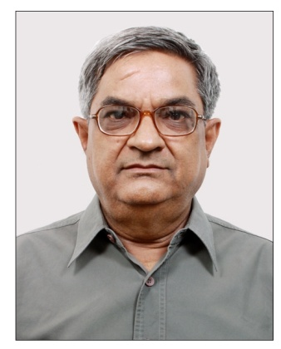

Naushad Ali Azad
M.Sc. (Stat.), MA (Eco), Ph.D. (International Economics)

Brief Biodata:
Formerly a Professor of Economics at Jamia Millia Islamia (Central University), New Delhi, Naushad Ali Azad did his Ph.D. in International Economics from Jawaharlal Nehru University, New Delhi in 1992 on the topic “Trade Performance and Trade Distribution - A Study of North V/S South”. Having more than 40 years’ experience of teaching and research, Prof. Azad has published research papers in reputed journals, contributed articles in books and delivered lectures in India and abroad. His teaching and research interests are in the areas of Research Methods, Trade Theory, Economic Integration, Sustainable Development and Financial Crisis.

Currently Vice-President, Naushad Ali Azad is founding member of Association for Environment and Development Research (AEDR), New Delhi – a non-profit research organization engaged in policy research since 1997.He was member of the general body of National Skill Development Agency (NSDA) under notification of Department of Economic Affairs, Ministry of Finance, Government of India. Besides teaching assignments in universities in Poland and Iraq, Prof Azad delivered lectures and conducted workshops for Ministry of Construction, Government of Vietnam on Sustainable Urban Development, Global Economic Crisis and Issues in Competitiveness.

